**Exp. 19 Storage Service**

**Aim:**

To create a Storage service using any Public Cloud Service Provider (Azure/GCP/AWS) and check the public accessibility of the stored file to demonstrate Storage as a Service.

**Procedure:**

* Sign in to Azure Portal
* Create a resource group
* Create a Storage Account
* Create a Blob container
* Upload a file in it
* Get the public URL for the uploaded file
* Check the accessibility

**Output:**

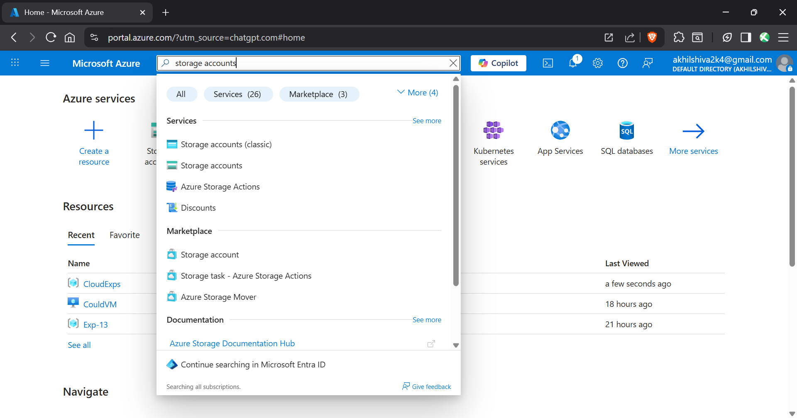

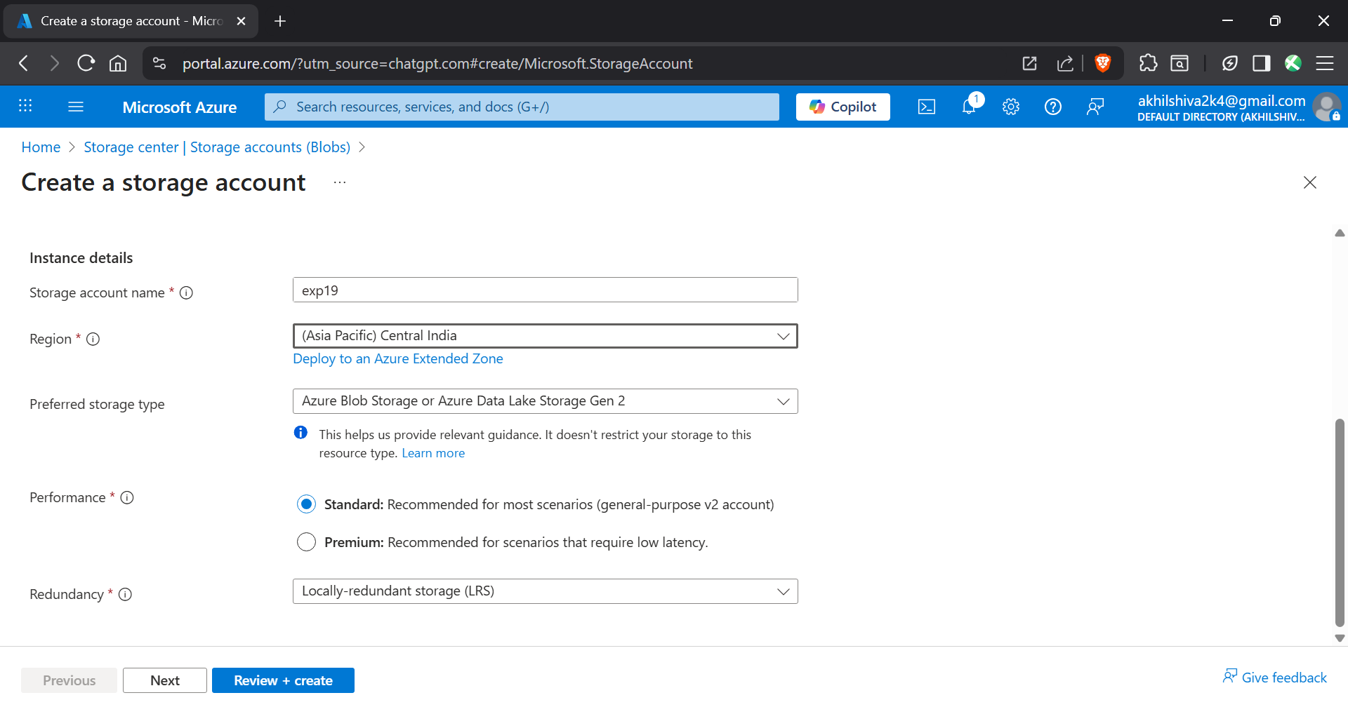

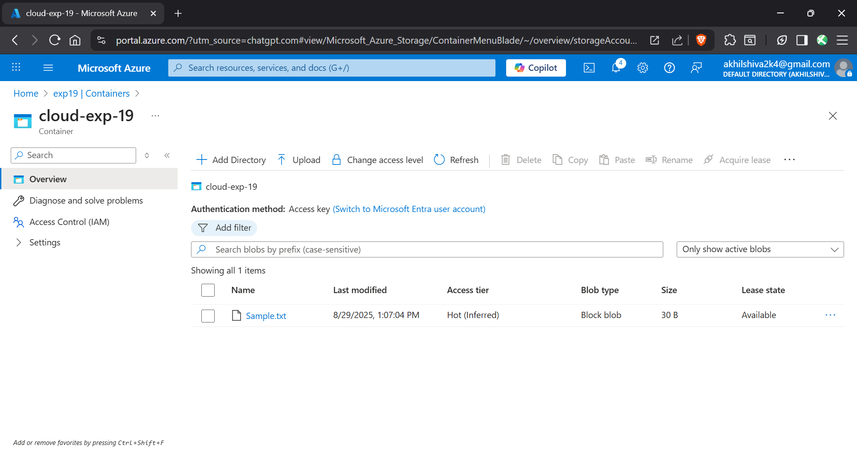

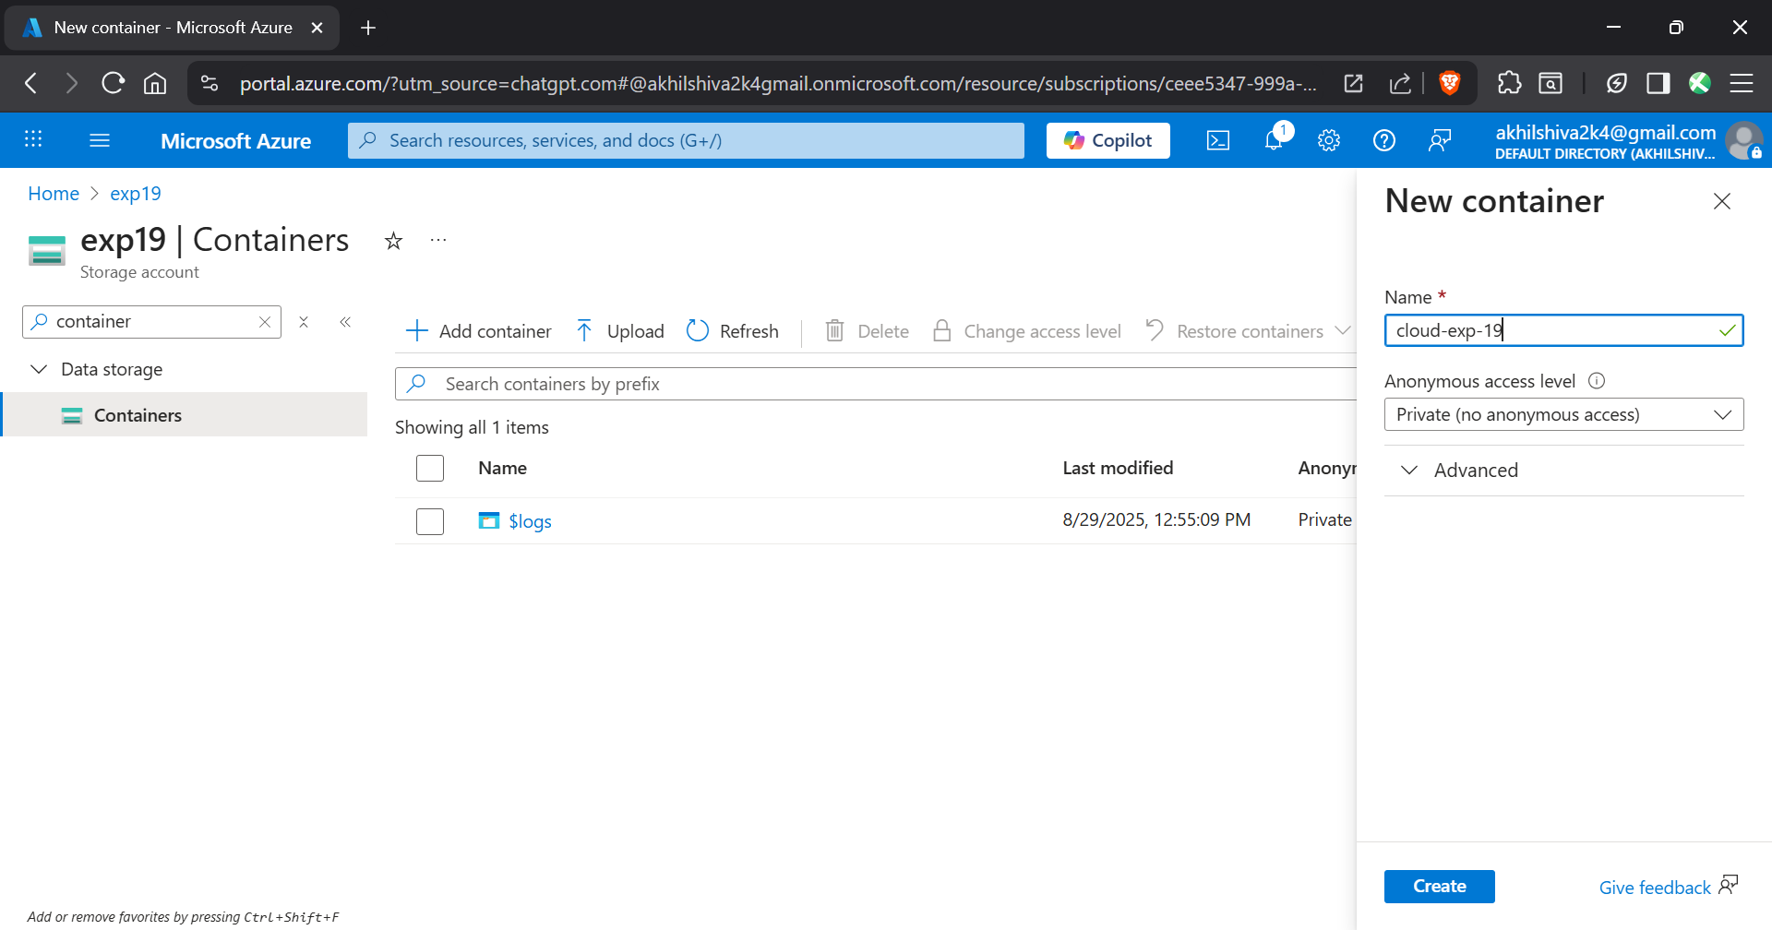

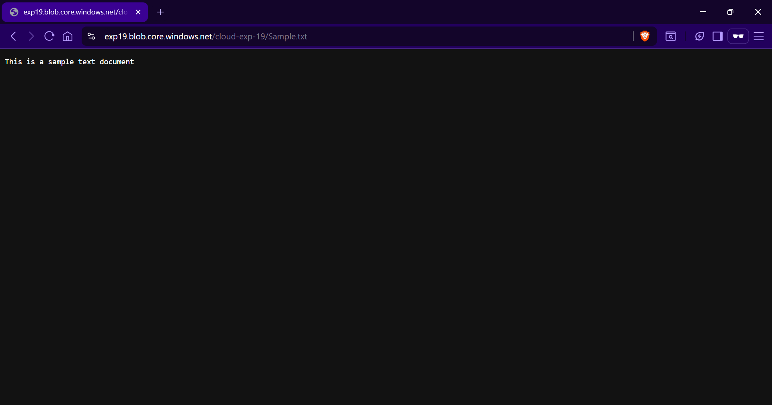

**Result:**

Thus the storage service was created successfully